**Assignment no:1**

**Name:Bhairav Chaudhari**

**Roll no:3**

**Subject:R programing**

1. Write a R program to read an input from the user and check whether it is

odd or even.

cat("enter a number:")

a<- readLines("stdin",n=1);

cat("You entered")

c=as.numeric(a);

cat("\n")

b=c%%2

if(b==0)

{print("Even")

}else

{print("Odd")}

O/P:

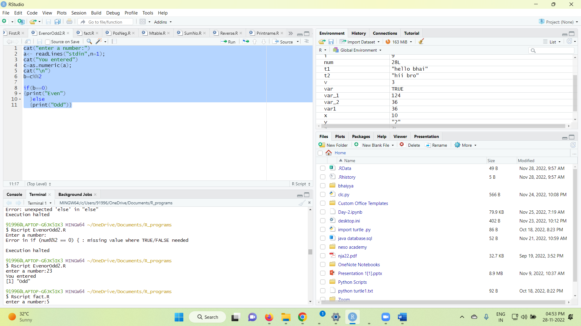

2. Write a R program to find factorial of a number

cat("enter a number:")

a<- readLines("stdin",n=1);

cat("You entered")

num=as.numeric(a);

cat("\n")

fact=1

for (i in 1:num) {

fact=fact*i

print(paste("The Factorial of",num,"is",fact))

}

O/P:

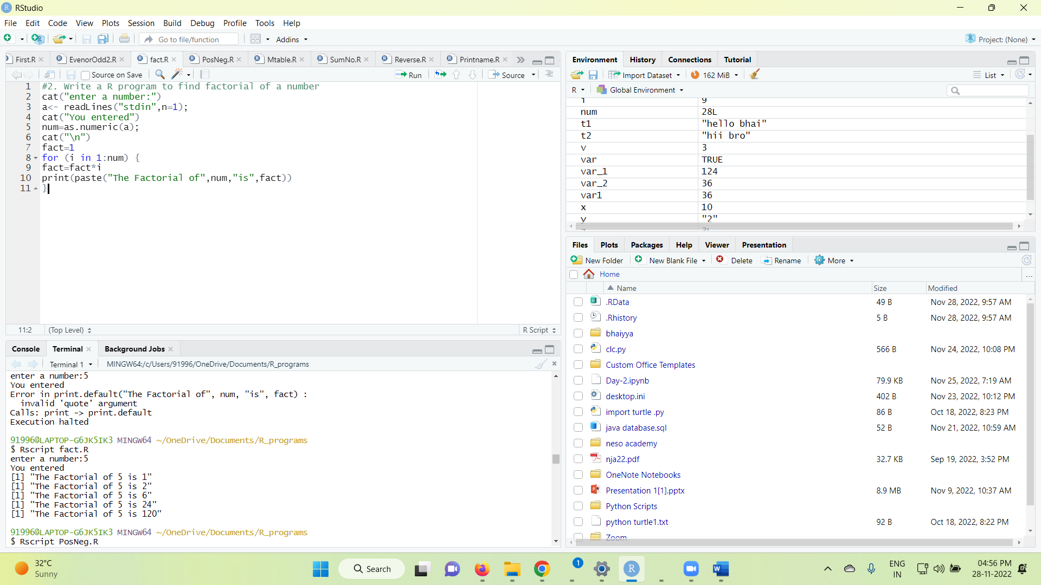

3. Write a R program to check whether the given number is positive,

negative or zero.

cat("enter a number:")

a<- readLines("stdin",n=1);

cat("You entered")

num=as.numeric(a);

cat("\n")

if(num>0){

print("Positive number")

}else if(num==0){

print("Zero")

}else{

print("Negative Number")

}

O/P:

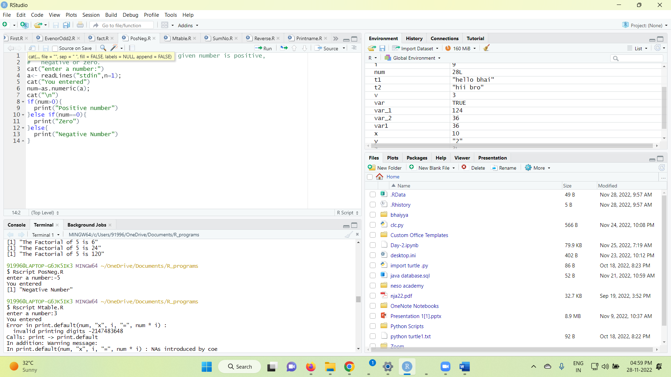

4. Write an R program to print Multiplication table of a given number

cat("enter a number:")

a<- readLines("stdin",n=1);

cat("You entered")

num=as.numeric(a);

cat("\n")

for (i in 1:10) {

print(paste(num,"x",i,"=",num*i))

}

O/P:

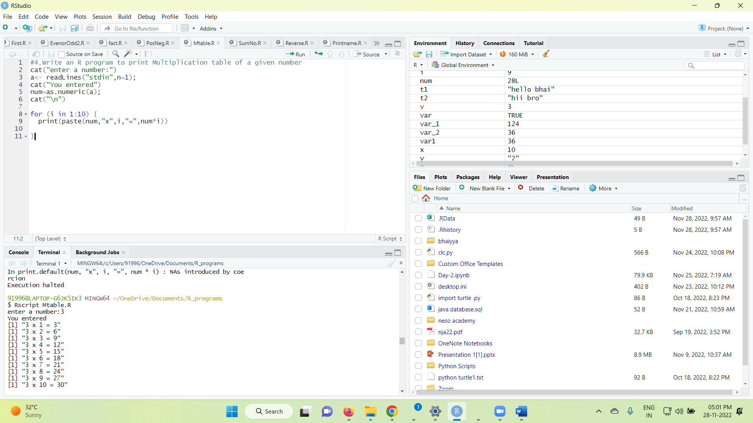

5. Write a R program to find sum of n natural numbers

cat("enter a number:")

a<- readLines("stdin",n=1);

cat("You entered")

num=as.numeric(a);

cat("\n")

if(num<0){

print("Enter positive number")

}else{

sum=0;

while(num>0){

sum=sum +num

num=num-1

}

cat("The sum of nos is:",sum)

}

O/P:

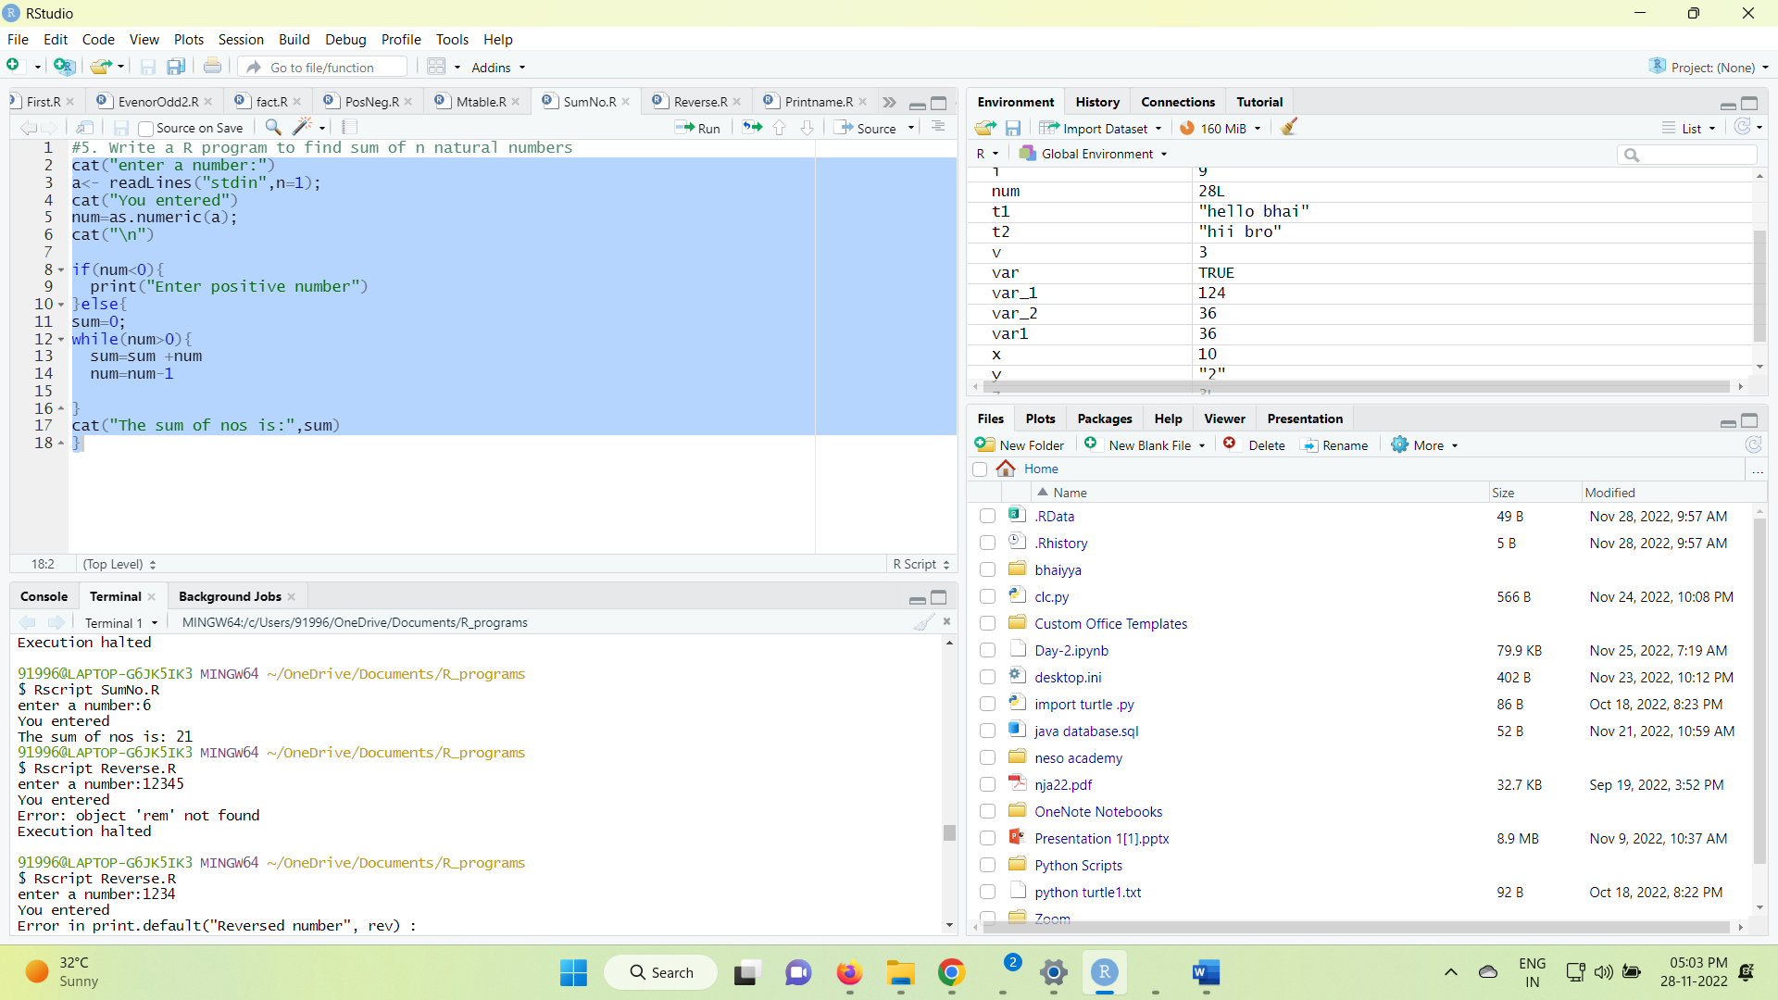

6. Write a R program to find reverse of a number

cat("enter a number:")

a<- readLines("stdin",n=1);

cat("You entered")

num=as.numeric(a);

cat("\n")

rev=0

while (num !=0) {

rem= num%%10

rev=rev*10 +rem

num=num%/%10

}

cat("Reversed number:",rev)

O/P:

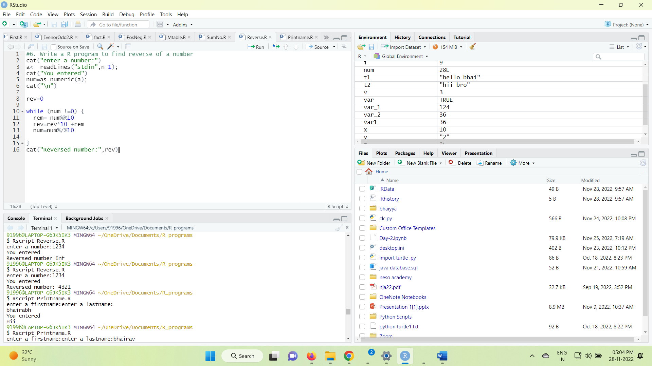

7. Write a R program to read first name, last name of a person and print

the result as Hi name of the person

t1=cat("enter a firstname:")

a<- readLines("stdin",n=1);

t2=cat("enter a lastname:")

b<- readLines("stdin",n=1);

cat("You entered:-")

#cat(t1,"\n",t2)

cat("hii",a,b)

O/P:

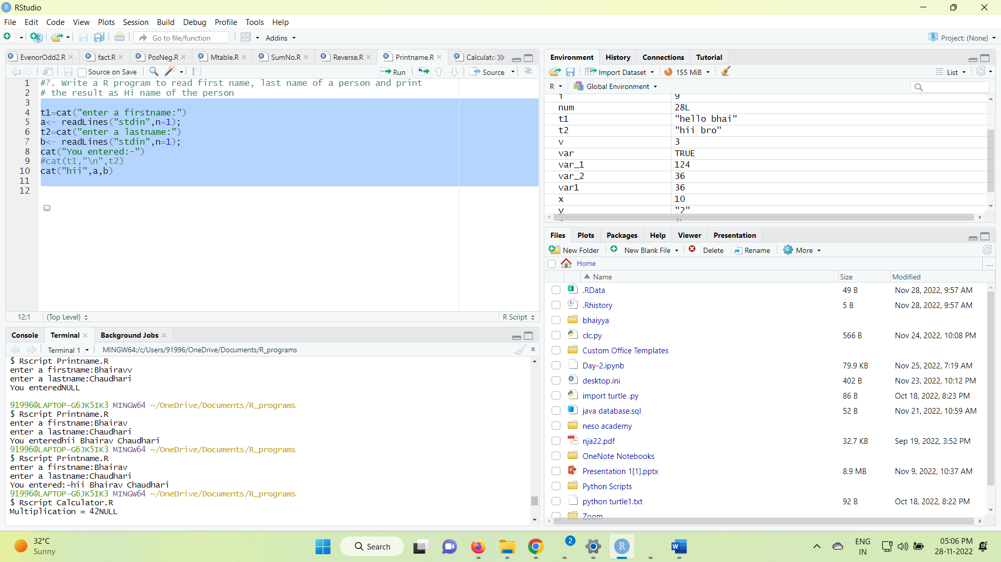

8. Write a R program using switch to simulate a calculator.

val1 = 5

val2 = 7

result <- switch( 3,

cat("Addition =", val1 + val2),

cat("Subtraction =", val1 - val2),

cat("Multiplication =", val1 * val2),

cat("Division = ", val1 / val2)

)

print(result)

O/P:

